Week 8: Jenkins Automation
- Hands-on practice on manual creation of Jenkins pipeline using Maven projects from Github
- Create the job and build the pipeline for maven-java and maven-web project.
- Questions on Jenkins
- Upload the Screenshots.

- Steps for MavenJava Automation:
Maven Java Automation Steps:
Step 1: Open Jenkins (localhost:8080)
├── Click on "New Item" (left side menu)
Step 2: Create Freestyle Project (e.g., MavenJava_Build)
├── Enter project name (e.g., MavenJava_Build)
├── Click "OK"
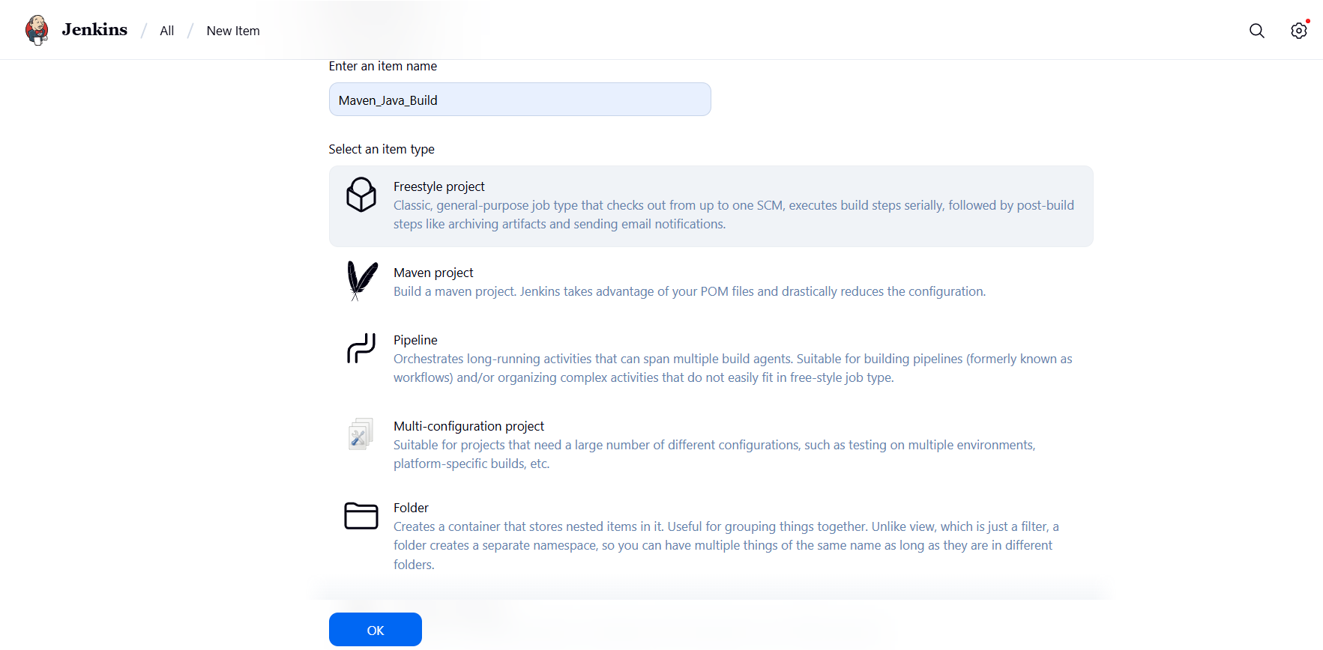
└── Configure the project:
├── Description: "Java Build demo"
├── Source Code Management:
└── Git repository URL: [GitMavenJava repo URL]
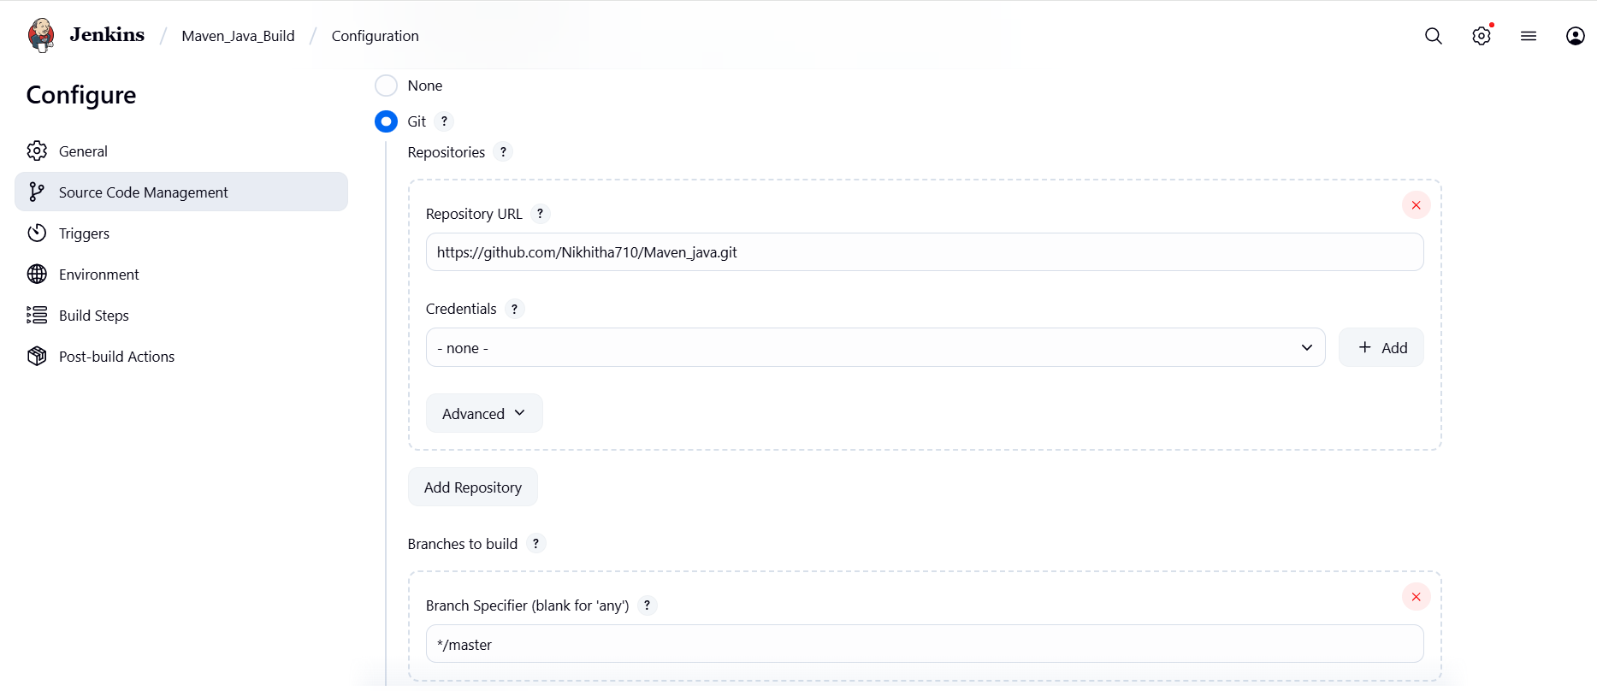
├── Branches to build: */Main or */master
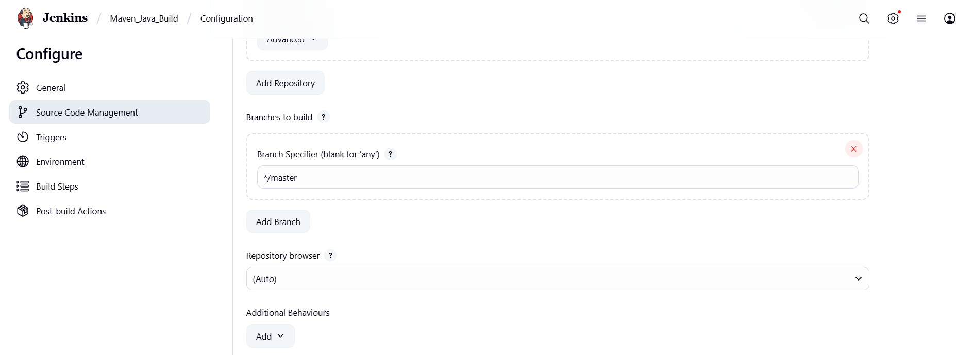
└── Build Steps:
├── Add Build Step -> "Invoke top-level Maven targets"
└── Maven version: MAVEN_HOME
└── Goals: clean
├── Add Build Step -> "Invoke top-level Maven targets"
└── Maven version: MAVEN_HOME
└── Goals: install
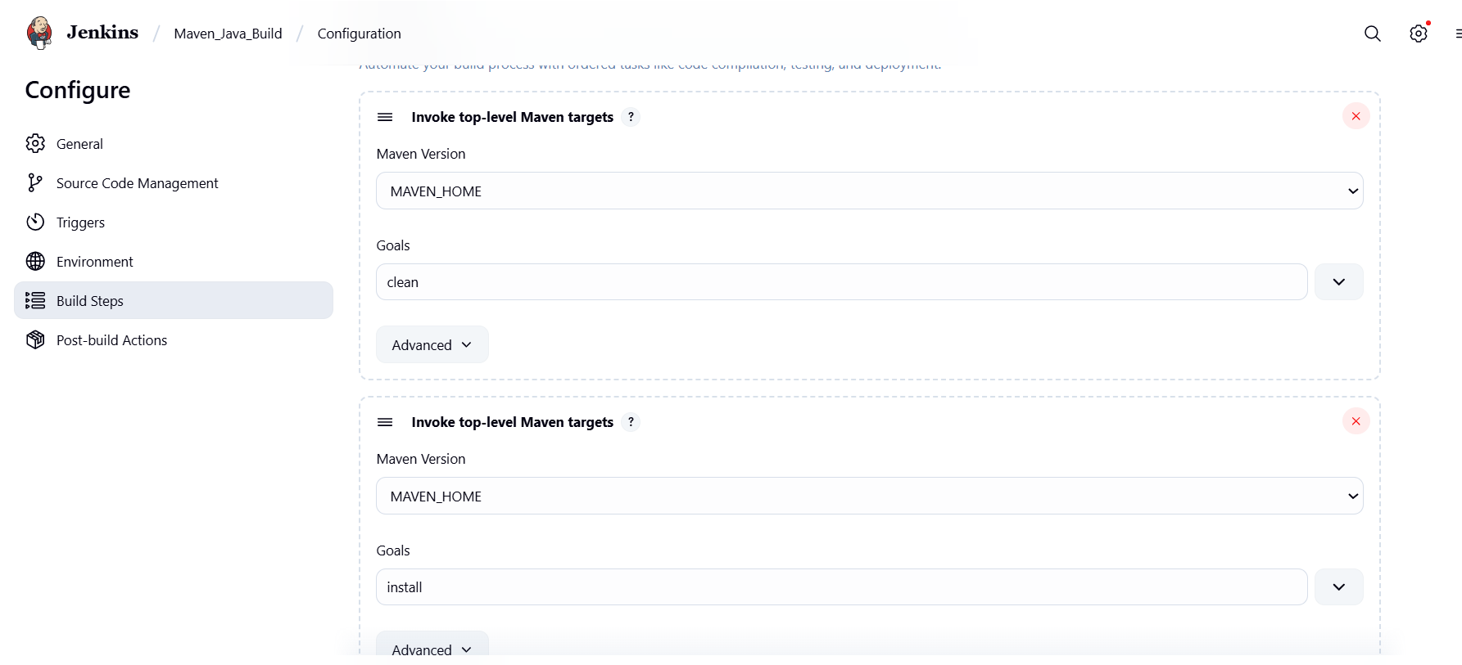
└── Post-build Actions:
├── Add Post Build Action -> "Archive the artifacts"
└── Files to archive: **/*
├── Add Post Build Action -> "Build other projects"
└── Projects to build: MavenJava_Test
└── Trigger: Only if build is stable
└── Apply and Save
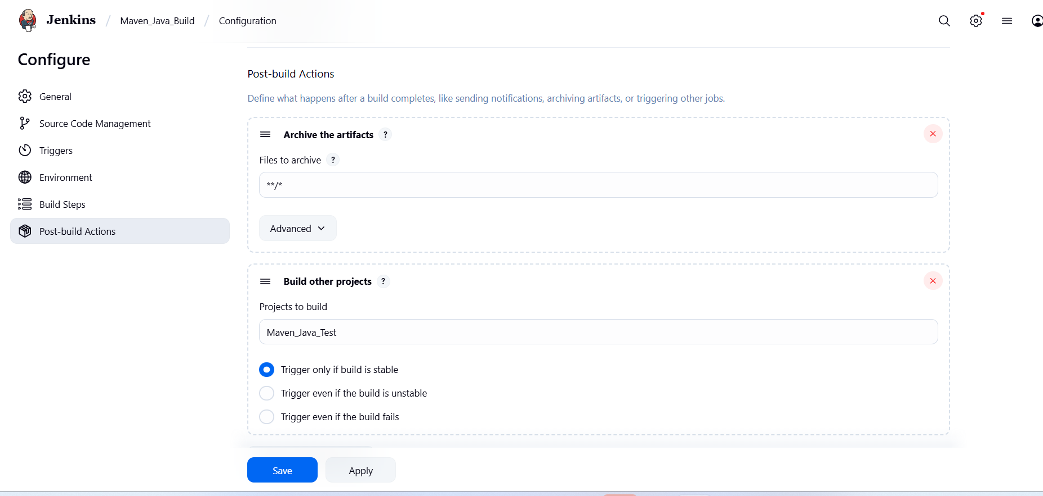

└── Step 3: Create Freestyle Project (e.g., MavenJava_Test)
├── Enter project name (e.g., MavenJava_Test)
├── Click "OK"
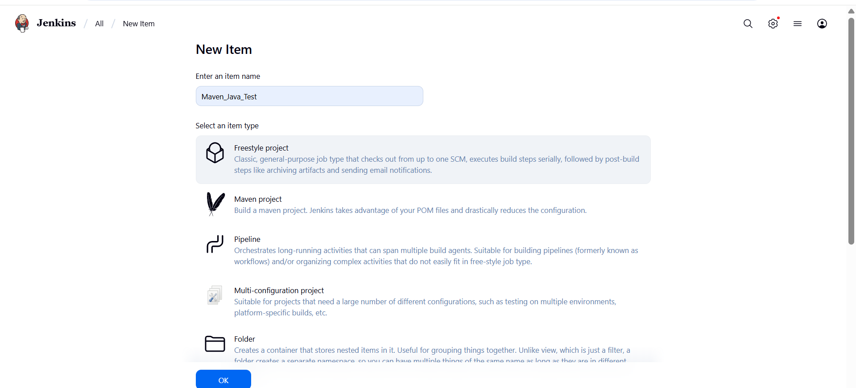
└── Configure the project:
├── Description: "Test demo"
├── Build Environment:
└── Check: "Delete the workspace before build starts"
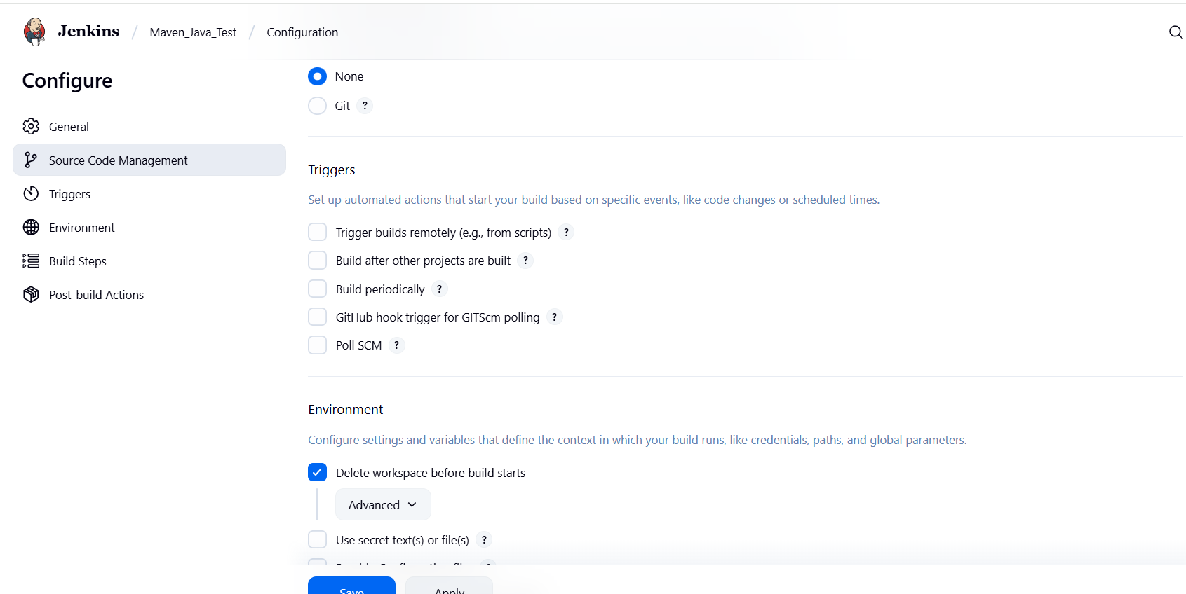
├── Add Build Step -> "Copy artifacts from another project"
└── Project name: MavenJava_Build
└── Build: Stable build only // tick at this
└── Artifacts to copy: **/*
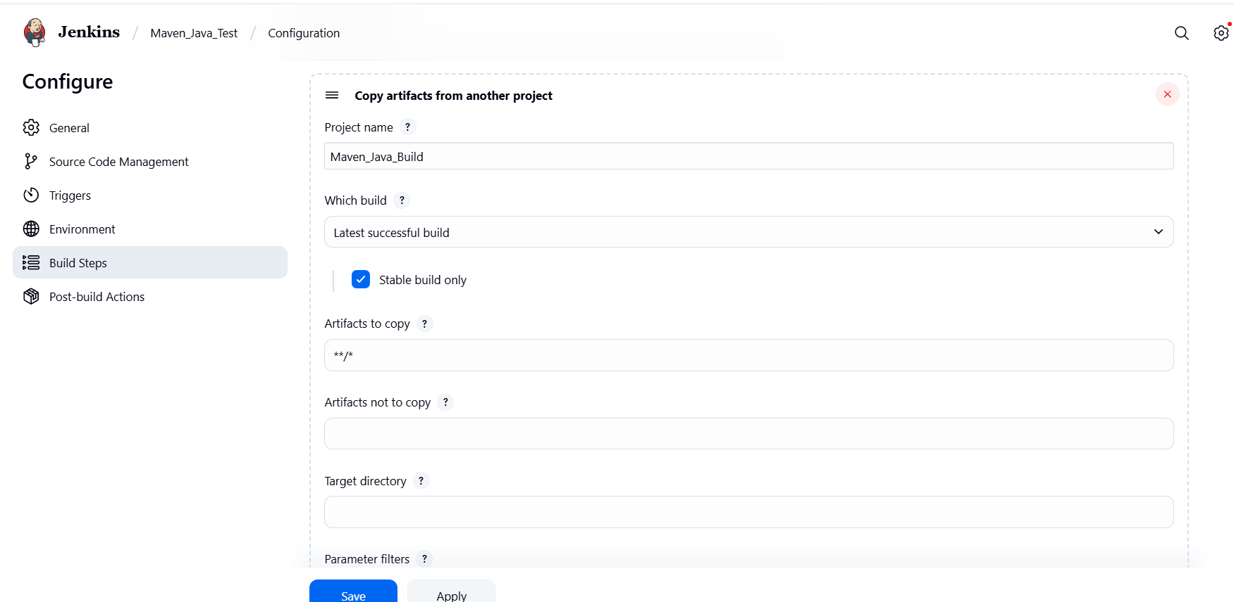
├── Add Build Step -> "Invoke top-level Maven targets"
└── Maven version: MAVEN_HOME
└── Goals: test
└── Post-build Actions:
├── Add Post Build Action -> "Archive the artifacts"
└── Files to archive: **/*
└── Apply and Save
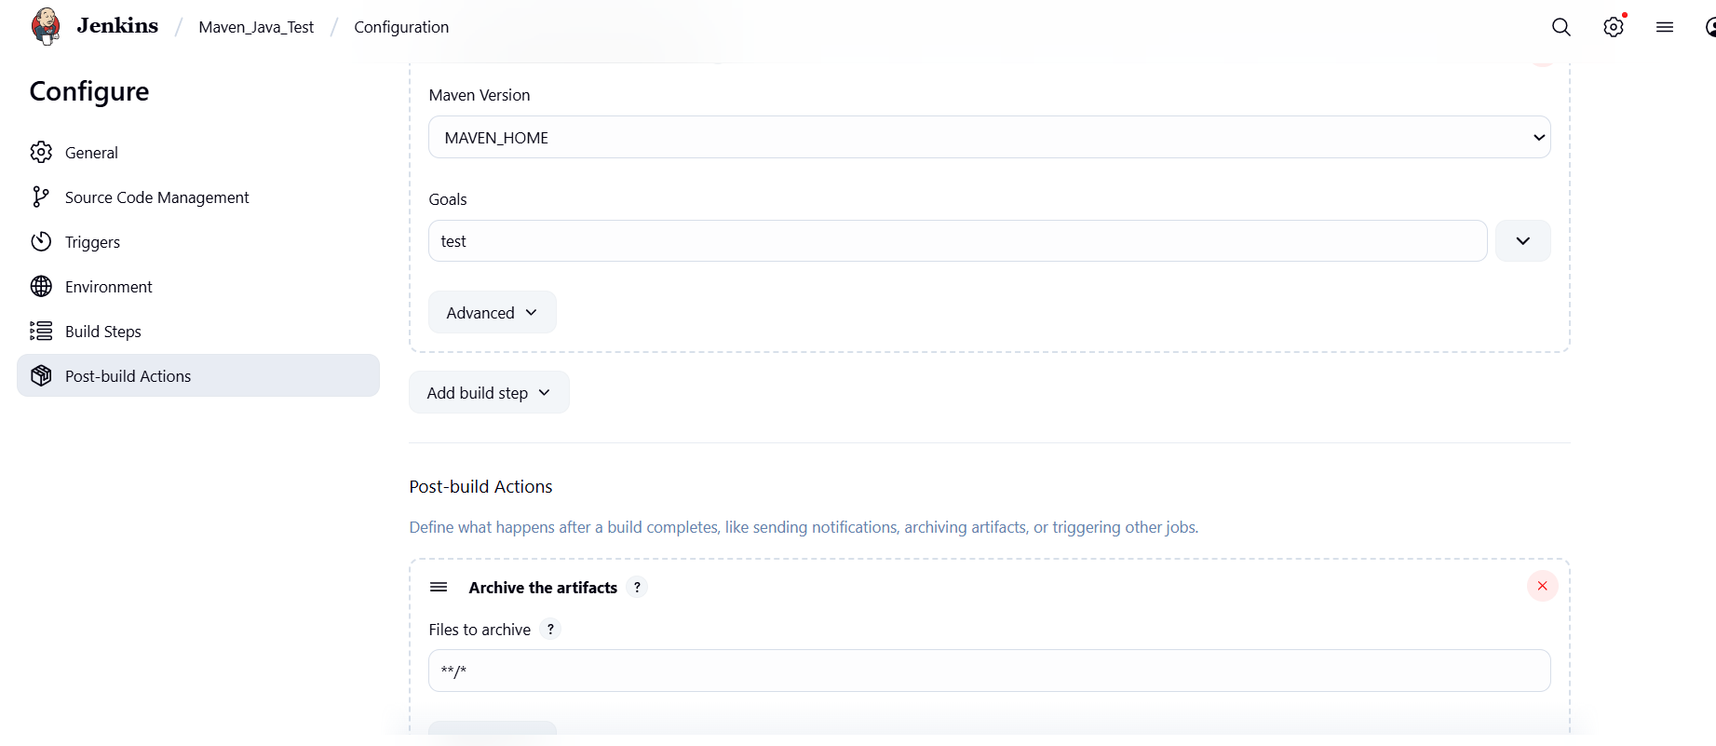

└── Step 4: Create Pipeline View for Maven Java project
├── Click "+" beside "All" on the dashboard
├── Enter name: MavenJava_Pipeline
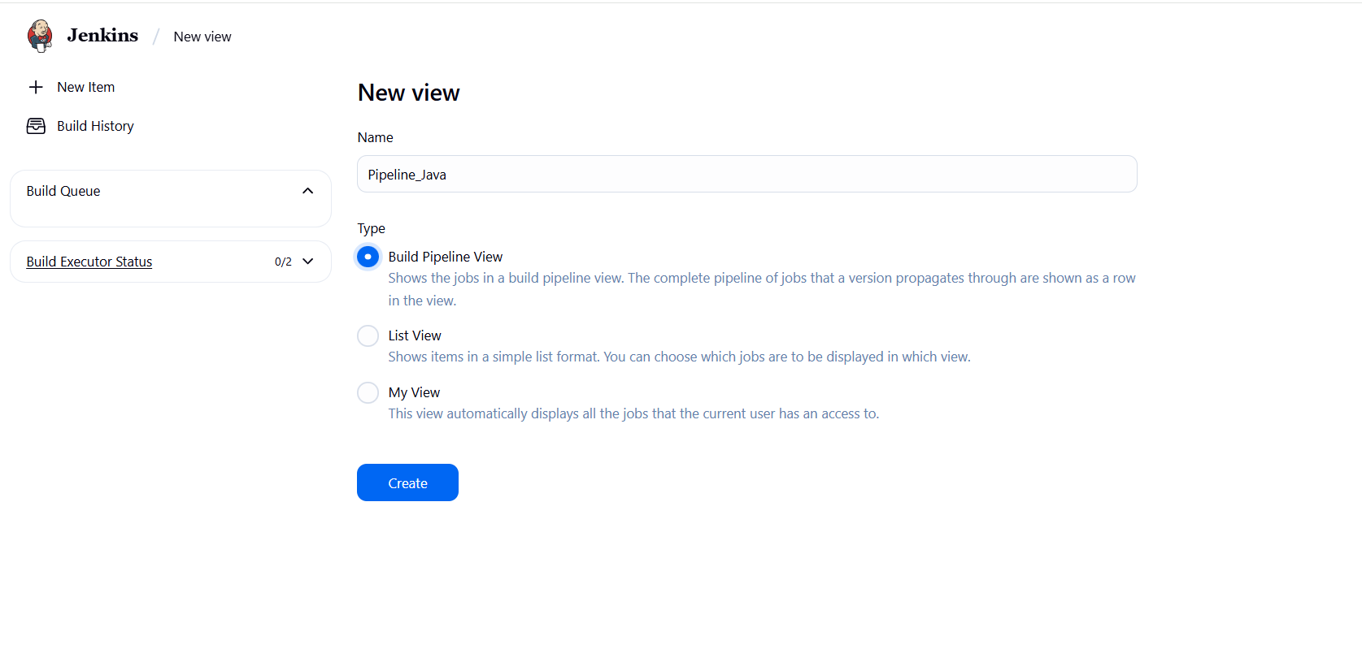
├── Select "Build pipeline view" // tick here
|--- create
└── Pipeline Flow:
├── Layout: Based on upstream/downstream relationship
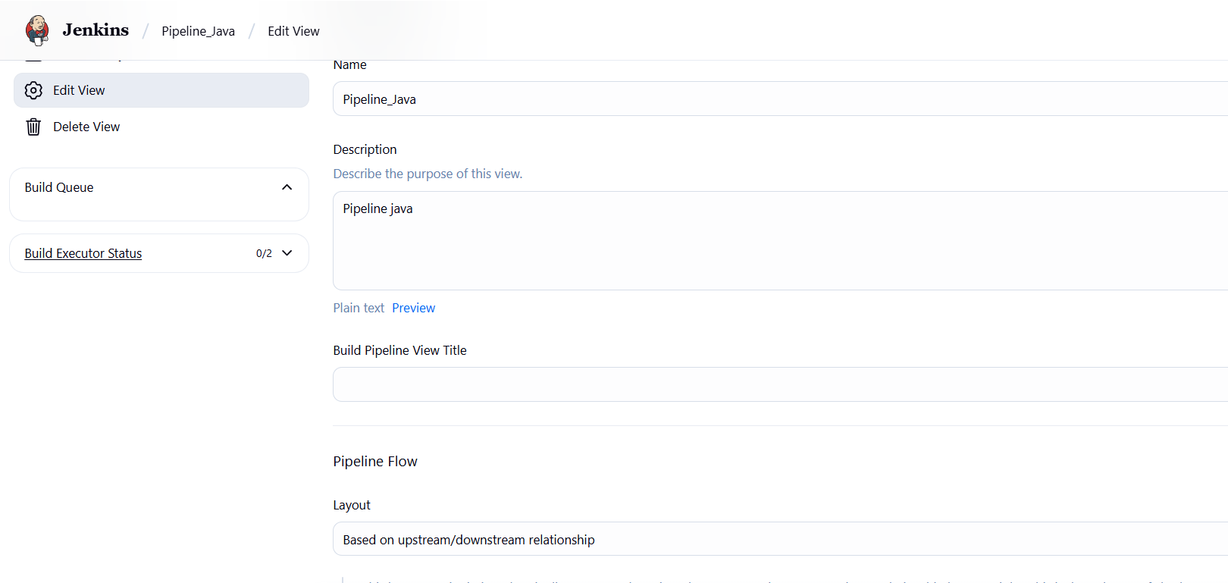
├── Initial job: MavenJava_Build
└── Apply and Save OK
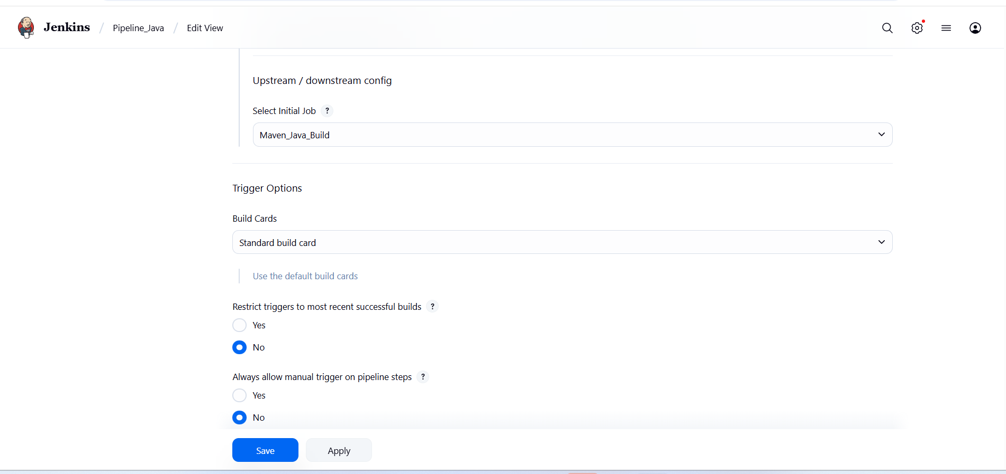

└── Step 5: Run the Pipeline and Check Output
├── Click on the trigger to run the pipeline
├── click on the small black box to open the console to check if the build is success
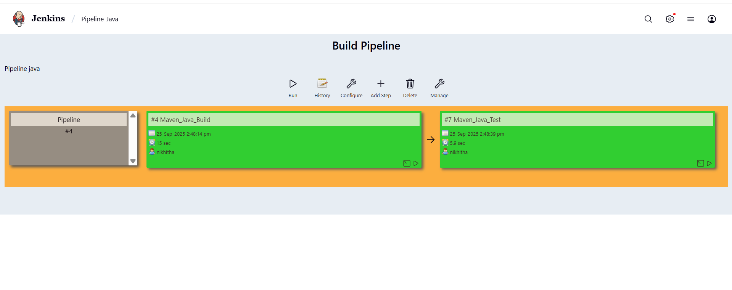
Console Output:
Started by user Nikhitha
Running as SYSTEM
Building in workspace C:\ProgramData\Jenkins\.jenkins\workspace\Maven_Java_Build
The recommended git tool is: NONE
No credentials specified
> git.exe rev-parse --resolve-git-dir C:\ProgramData\Jenkins\.jenkins\workspace\Maven_Java_Build\.git # timeout=10
Fetching changes from the remote Git repository
> git.exe config remote.origin.url https://github.com/Nikhitha710/Maven_java.git # timeout=10
Fetching upstream changes from https://github.com/Nikhitha710/Maven_java.git
> git.exe --version # timeout=10
> git --version # 'git version 2.49.0.windows.1'
> git.exe fetch --tags --force --progress -- https://github.com/Nikhitha710/Maven_java.git +refs/heads/*:refs/remotes/origin/* # timeout=10
> git.exe rev-parse "refs/remotes/origin/master^{commit}" # timeout=10
Checking out Revision 7442e73698ceb8ff6dc8ee356f58fa3c270e8699 (refs/remotes/origin/master)
> git.exe config core.sparsecheckout # timeout=10
> git.exe checkout -f 7442e73698ceb8ff6dc8ee356f58fa3c270e8699 # timeout=10
Commit message: "java"
> git.exe rev-list --no-walk 7442e73698ceb8ff6dc8ee356f58fa3c270e8699 # timeout=10
[Maven_Java_Build] $ cmd.exe /C "C:\Users\RAMM\Downloads\apache-maven-3.9.10-bin\apache-maven-3.9.10\bin\mvn.cmd clean && exit %%ERRORLEVEL%%"
[INFO] Scanning for projects...
[INFO]
[INFO] ----------------------------< SELAB:JAVA1 >-----------------------------
[INFO] Building JAVA1 0.0.1-SNAPSHOT
[INFO] from pom.xml
[INFO] --------------------------------[ jar ]---------------------------------
[INFO]
[INFO] --- clean:3.4.0:clean (default-clean) @ JAVA1 ---
[INFO] Deleting C:\ProgramData\Jenkins\.jenkins\workspace\Maven_Java_Build\target
[INFO] ------------------------------------------------------------------------
[INFO] BUILD SUCCESS
[INFO] ------------------------------------------------------------------------
[INFO] Total time: 0.394 s
[INFO] Finished at: 2025-09-25T14:48:23+05:30
[INFO] ------------------------------------------------------------------------
[Maven_Java_Build] $ cmd.exe /C "C:\Users\RAMM\Downloads\apache-maven-3.9.10-bin\apache-maven-3.9.10\bin\mvn.cmd install && exit %%ERRORLEVEL%%"
[INFO] Scanning for projects...
[INFO]
[INFO] ----------------------------< SELAB:JAVA1 >-----------------------------
[INFO] Building JAVA1 0.0.1-SNAPSHOT
[INFO] from pom.xml
[INFO] --------------------------------[ jar ]---------------------------------
[INFO]
[INFO] --- resources:3.3.1:resources (default-resources) @ JAVA1 ---
[INFO] skip non existing resourceDirectory C:\ProgramData\Jenkins\.jenkins\workspace\Maven_Java_Build\src\main\resources
[INFO]
[INFO] --- compiler:3.13.0:compile (default-compile) @ JAVA1 ---
[INFO] Recompiling the module because of changed source code.
[INFO] Compiling 1 source file with javac [debug release 17] to target\classes
[INFO]
[INFO] --- resources:3.3.1:testResources (default-testResources) @ JAVA1 ---
[INFO] skip non existing resourceDirectory C:\ProgramData\Jenkins\.jenkins\workspace\Maven_Java_Build\src\test\resources
[INFO]
[INFO] --- compiler:3.13.0:testCompile (default-testCompile) @ JAVA1 ---
[INFO] Recompiling the module because of changed dependency.
[INFO] Compiling 1 source file with javac [debug release 17] to target\test-classes
[INFO]
[INFO] --- surefire:3.3.0:test (default-test) @ JAVA1 ---
[INFO] Using auto detected provider org.apache.maven.surefire.junitplatform.JUnitPlatformProvider
[INFO]
[INFO] -------------------------------------------------------
[INFO] T E S T S
[INFO] -------------------------------------------------------
[INFO] Running SELAB.JAVA1.AppTest
[INFO] Tests run: 1, Failures: 0, Errors: 0, Skipped: 0, Time elapsed: 0.064 s -- in SELAB.JAVA1.AppTest
[INFO]
[INFO] Results:
[INFO]
[INFO] Tests run: 1, Failures: 0, Errors: 0, Skipped: 0
[INFO]
[INFO]
[INFO] --- jar:3.4.2:jar (default-jar) @ JAVA1 ---
[INFO] Building jar: C:\ProgramData\Jenkins\.jenkins\workspace\Maven_Java_Build\target\JAVA1-0.0.1-SNAPSHOT.jar
[INFO]
[INFO] --- install:3.1.2:install (default-install) @ JAVA1 ---
[INFO] Installing C:\ProgramData\Jenkins\.jenkins\workspace\Maven_Java_Build\pom.xml to C:\WINDOWS\system32\config\systemprofile\.m2\repository\SELAB\JAVA1\0.0.1-SNAPSHOT\JAVA1-0.0.1-SNAPSHOT.pom
[INFO] Installing C:\ProgramData\Jenkins\.jenkins\workspace\Maven_Java_Build\target\JAVA1-0.0.1-SNAPSHOT.jar to C:\WINDOWS\system32\config\systemprofile\.m2\repository\SELAB\JAVA1\0.0.1-SNAPSHOT\JAVA1-0.0.1-SNAPSHOT.jar
[INFO] ------------------------------------------------------------------------
[INFO] BUILD SUCCESS
[INFO] ------------------------------------------------------------------------
[INFO] Total time: 3.989 s
[INFO] Finished at: 2025-09-25T14:48:29+05:30
[INFO] ------------------------------------------------------------------------
Archiving artifacts
Triggering a new build of Maven_Java_Test
Finished: SUCCESS

Started by upstream project "Maven_Java_Build" build number 4
originally caused by:
Started by user Nikhitha
Started by user Nikhitha
Started by upstream project "Maven_Java_Build" build number 4
originally caused by:
Started by user Nikhitha
Running as SYSTEM
Building in workspace C:\ProgramData\Jenkins\.jenkins\workspace\Maven_Java_Test
[WS-CLEANUP] Deleting project workspace...
[WS-CLEANUP] Deferred wipeout is used...
[WS-CLEANUP] Done
Copied 20 artifacts from "Maven_Java_Build" build number 4
[Maven_Java_Test] $ cmd.exe /C "C:\Users\RAMM\Downloads\apache-maven-3.9.10-bin\apache-maven-3.9.10\bin\mvn.cmd test && exit %%ERRORLEVEL%%"
[INFO] Scanning for projects...
[INFO]
[INFO] ----------------------------< SELAB:JAVA1 >-----------------------------
[INFO] Building JAVA1 0.0.1-SNAPSHOT
[INFO] from pom.xml
[INFO] --------------------------------[ jar ]---------------------------------
[INFO]
[INFO] --- resources:3.3.1:resources (default-resources) @ JAVA1 ---
[INFO] skip non existing resourceDirectory C:\ProgramData\Jenkins\.jenkins\workspace\Maven_Java_Test\src\main\resources
[INFO]
[INFO] --- compiler:3.13.0:compile (default-compile) @ JAVA1 ---
[INFO] Recompiling the module because of added or removed source files.
[INFO] Compiling 1 source file with javac [debug release 17] to target\classes
[INFO]
[INFO] --- resources:3.3.1:testResources (default-testResources) @ JAVA1 ---
[INFO] skip non existing resourceDirectory C:\ProgramData\Jenkins\.jenkins\workspace\Maven_Java_Test\src\test\resources
[INFO]
[INFO] --- compiler:3.13.0:testCompile (default-testCompile) @ JAVA1 ---
[INFO] Recompiling the module because of changed dependency.
[INFO] Compiling 1 source file with javac [debug release 17] to target\test-classes
[INFO]
[INFO] --- surefire:3.3.0:test (default-test) @ JAVA1 ---
[INFO] Using auto detected provider org.apache.maven.surefire.junitplatform.JUnitPlatformProvider
[INFO]
[INFO] -------------------------------------------------------
[INFO] T E S T S
[INFO] -------------------------------------------------------
[INFO] Running SELAB.JAVA1.AppTest
[INFO] Tests run: 1, Failures: 0, Errors: 0, Skipped: 0, Time elapsed: 0.069 s -- in SELAB.JAVA1.AppTest
[INFO]
[INFO] Results:
[INFO]
[INFO] Tests run: 1, Failures: 0, Errors: 0, Skipped: 0
[INFO]
[INFO] ------------------------------------------------------------------------
[INFO] BUILD SUCCESS
[INFO] ------------------------------------------------------------------------
[INFO] Total time: 2.911 s
[INFO] Finished at: 2025-09-25T14:48:44+05:30
[INFO] ------------------------------------------------------------------------
Archiving artifacts
Finished: SUCCESS

Note :
- If build is success and the test project is also automatically triggered with name
“MavenJava_Test”
- The pipeline is successful if it is in green color as shown ->check the console of the test project
- The test project is successful and all the artifacts are archived successfully

II. Maven Web Automation Steps:
└── Step 1: Open Jenkins (localhost:8080)
├── Click on "New Item" (left side menu)

└── Step 2: Create Freestyle Project (e.g., MavenWeb_Build)
├── Enter project name (e.g., MavenWeb_Build)
├── Click "OK"
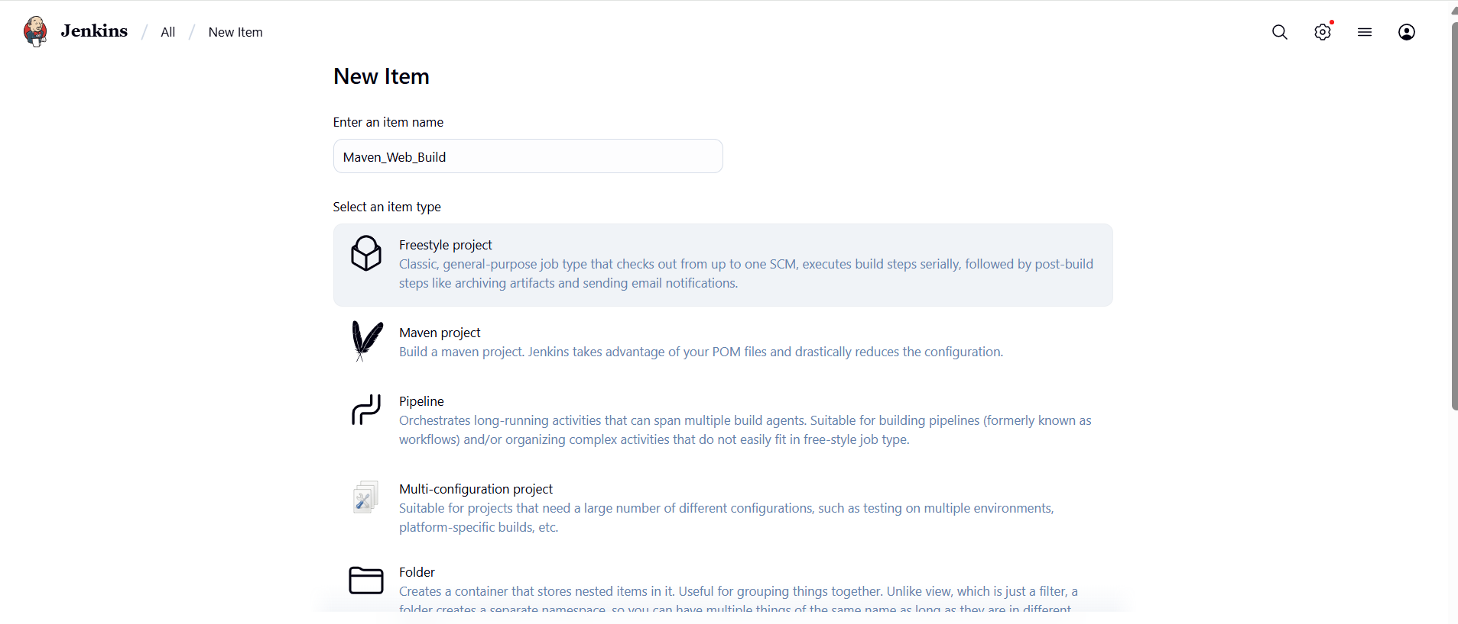
└── Configure the project:
├── Description: "Web Build demo"
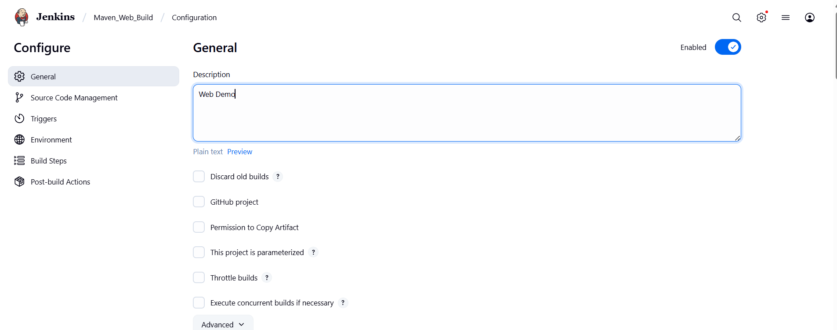
├── Source Code Management:
└── Git repository URL: [GitMavenWeb repo URL]
├── Branches to build: */Main or master
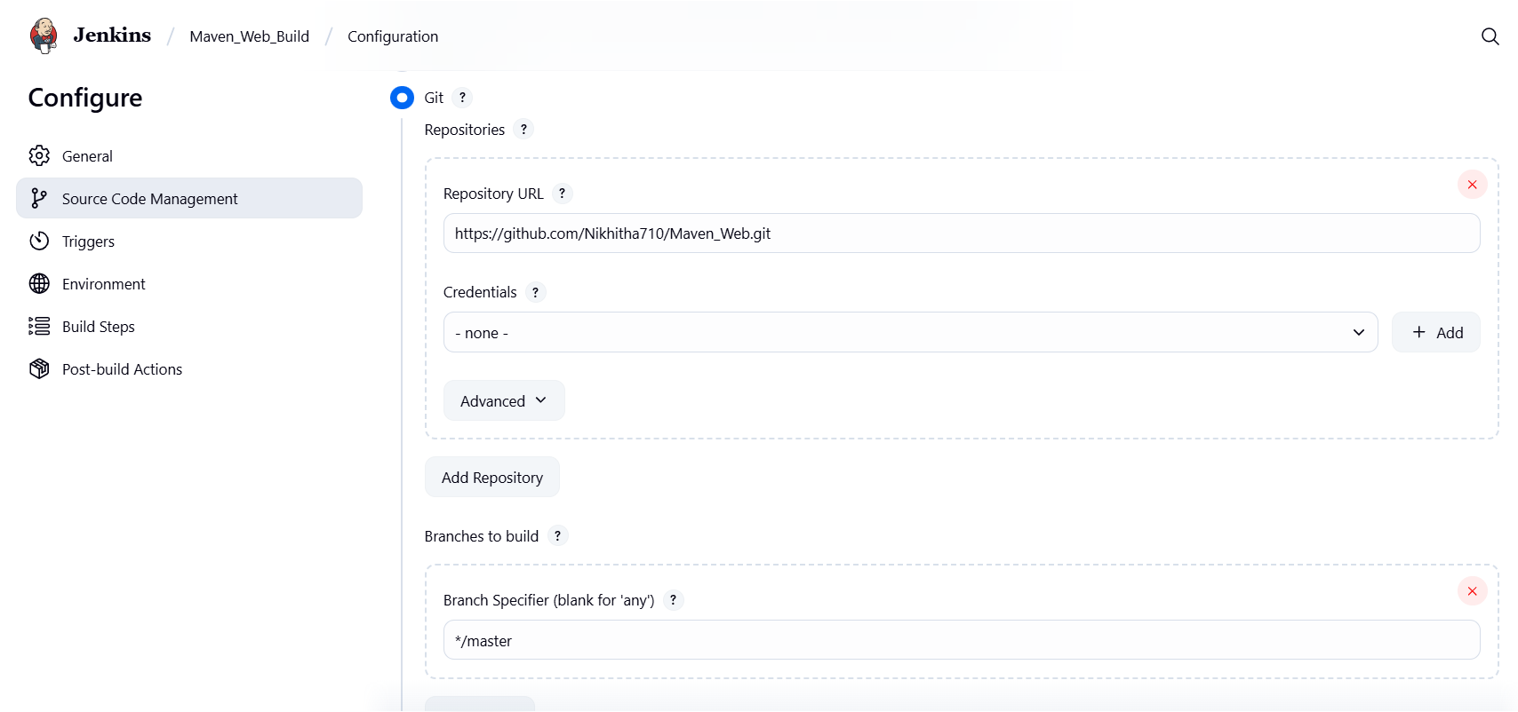
└── Build Steps:
├── Add Build Step -> "Invoke top-level Maven targets"
└── Maven version: MAVEN_HOME
└── Goals: clean
├── Add Build Step -> "Invoke top-level Maven targets"
└── Maven version: MAVEN_HOME
└── Goals: install
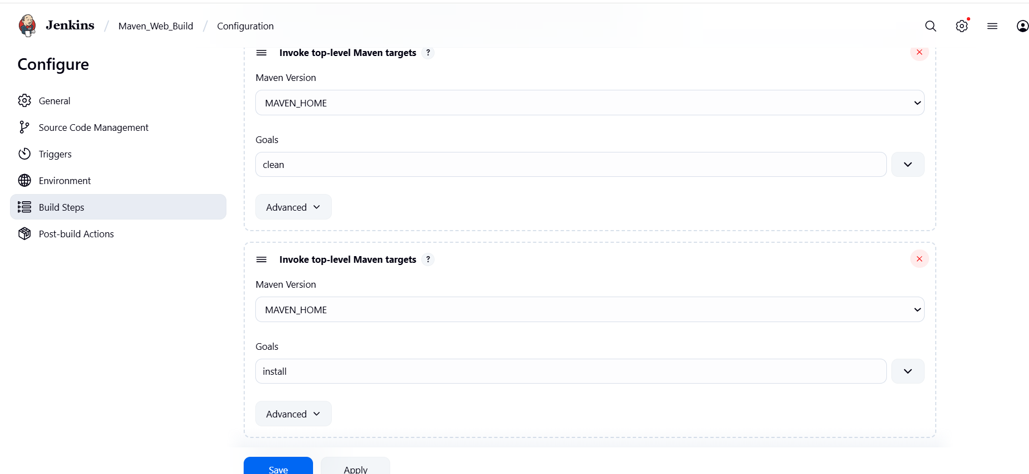

└── Post-build Actions:
├── Add Post Build Action -> "Archive the artifacts"
└── Files to archive: **/*
├── Add Post Build Action -> "Build other projects"
└── Projects to build: MavenWeb_Test
└── Trigger: Only if build is stable
└── Apply and Save
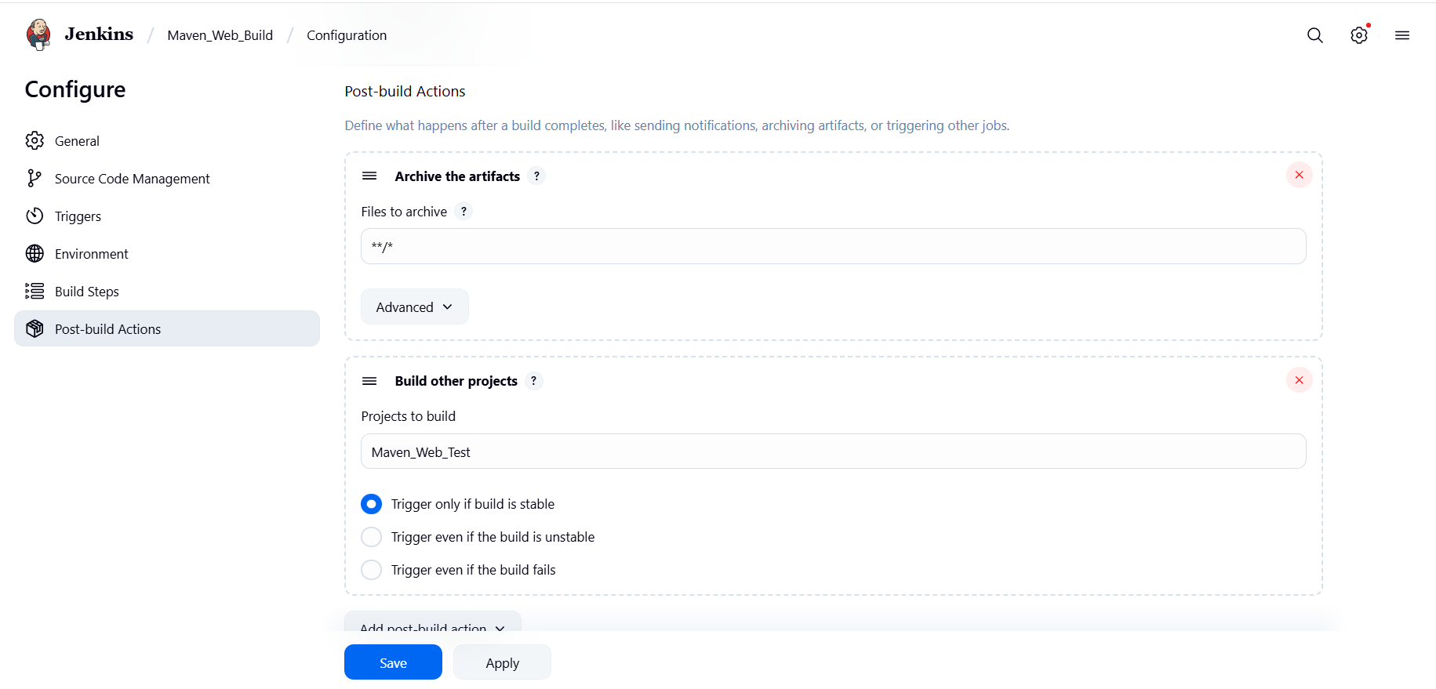

└── Step 3: Create Freestyle Project (e.g., MavenWeb_Test)
├── Enter project name (e.g., MavenWeb_Test)
├── Click "OK"
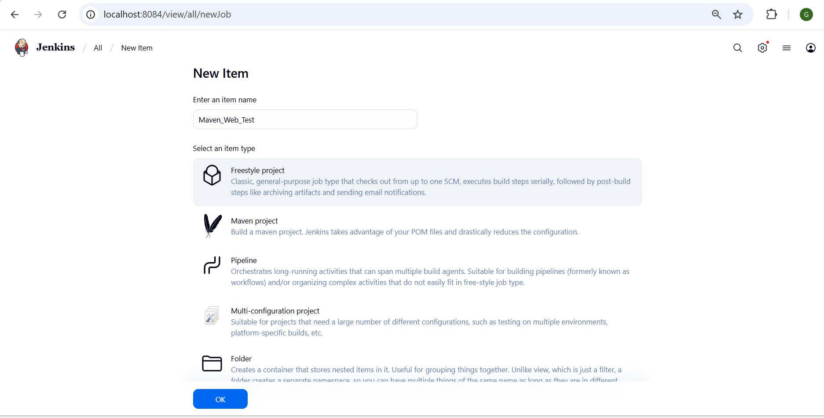
└── Configure the project:
├── Description: "Test demo"
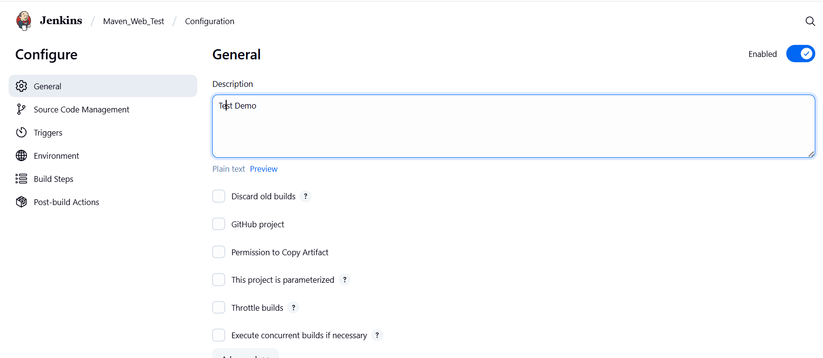
├── Build Environment:
└── Check: "Delete the workspace before build starts"
├── Add Build Step -> "Copy artifacts from another project"
└── Project name: MavenWeb_Build
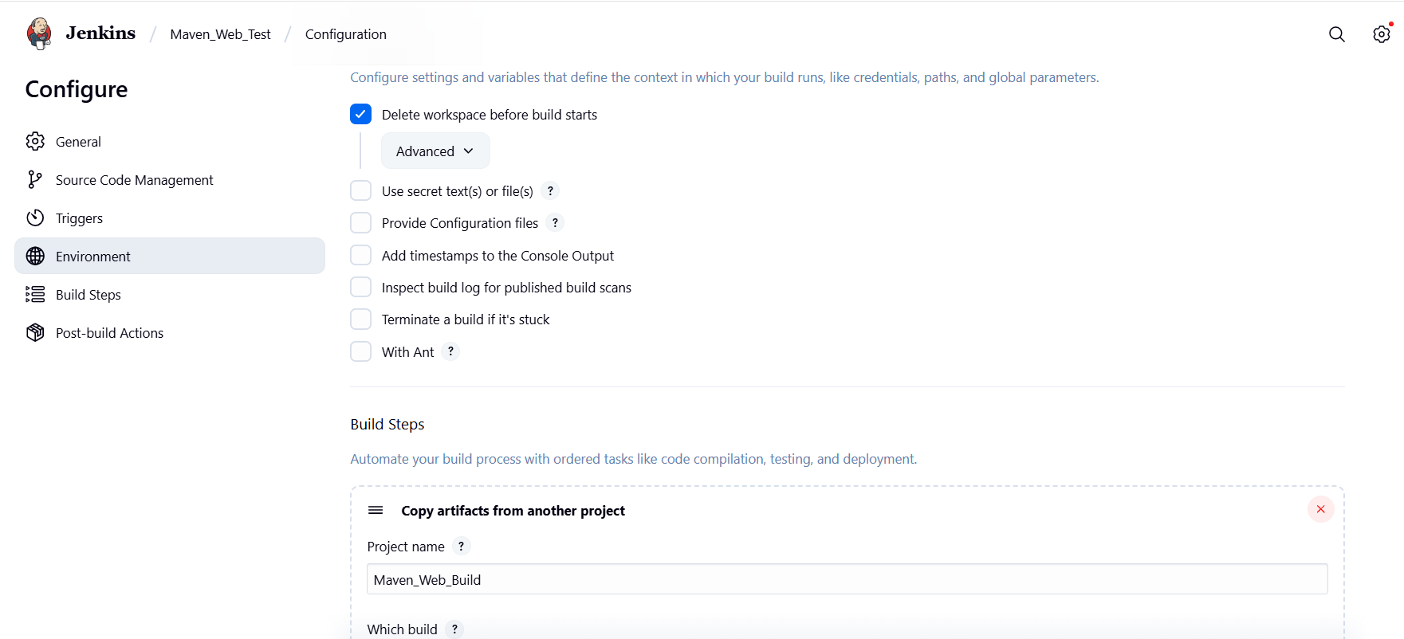
└── Build: Stable build only
└── Artifacts to copy: **/*
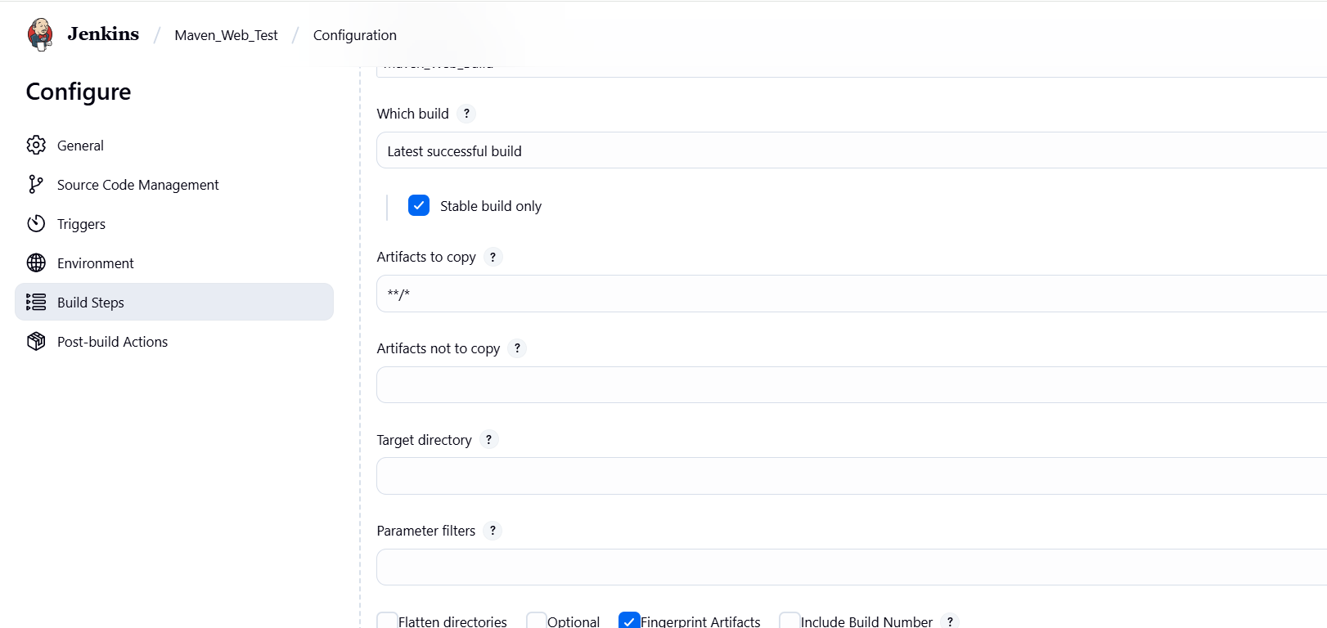
├── Add Build Step -> "Invoke top-level Maven targets"
└── Maven version: MAVEN_HOME
└── Goals: test
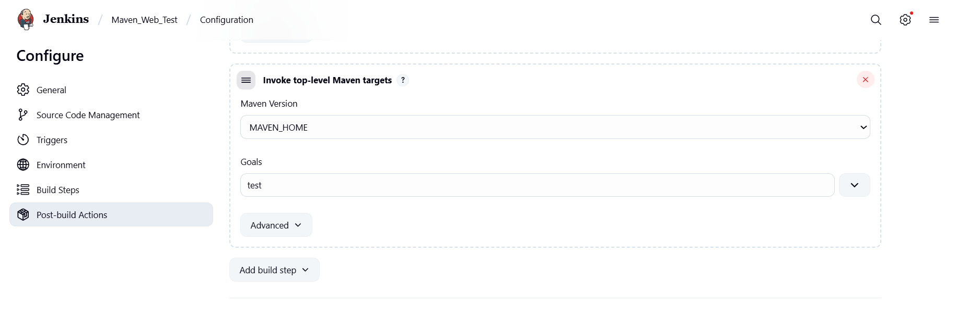
└── Post-build Actions:
├── Add Post Build Action -> "Archive the artifacts"
└── Files to archive: **/*
├── Add Post Build Action -> "Build other projects"
└── Projects to build: MavenWeb_Deploy
└── Apply and Save
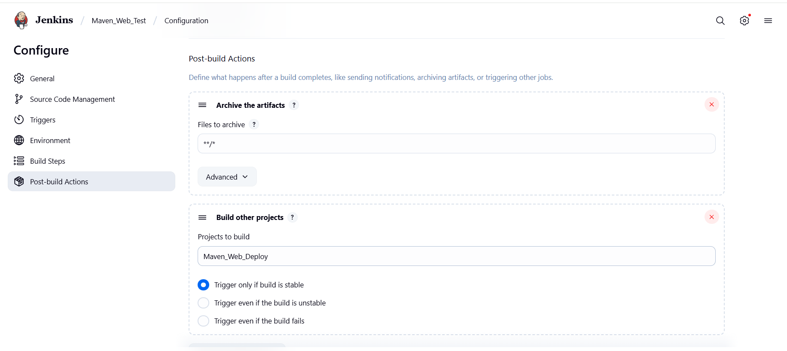

└── Step 4: Create Freestyle Project (e.g., MavenWeb_Deploy)
├── Enter project name (e.g., MavenWeb_Deploy)
├── Click "OK"
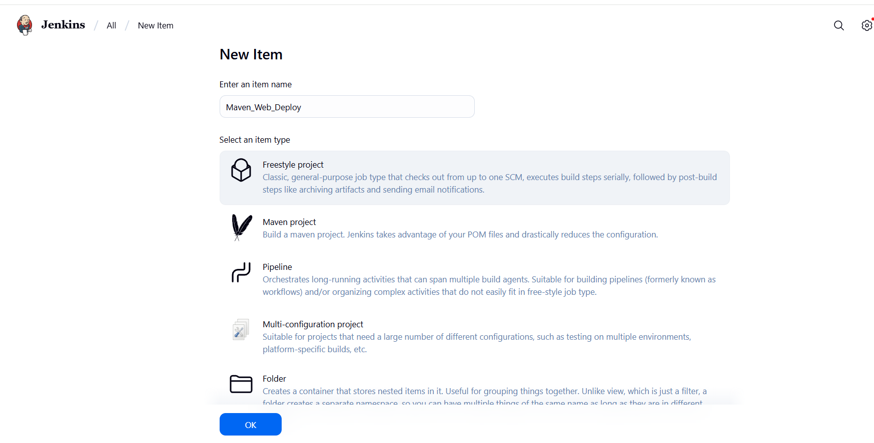
└── Configure the project:
├── Description: "Web Code Deployment"
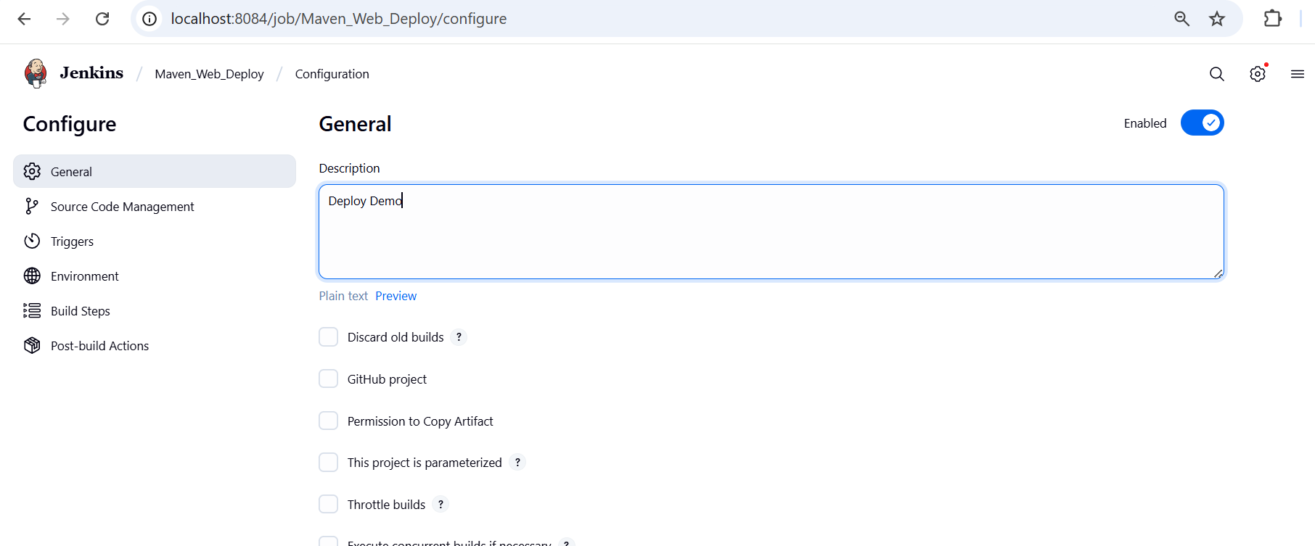
├── Build Environment:
└── Check: "Delete the workspace before build starts"
├── Add Build Step -> "Copy artifacts from another project"
└── Project name: MavenWeb_Test
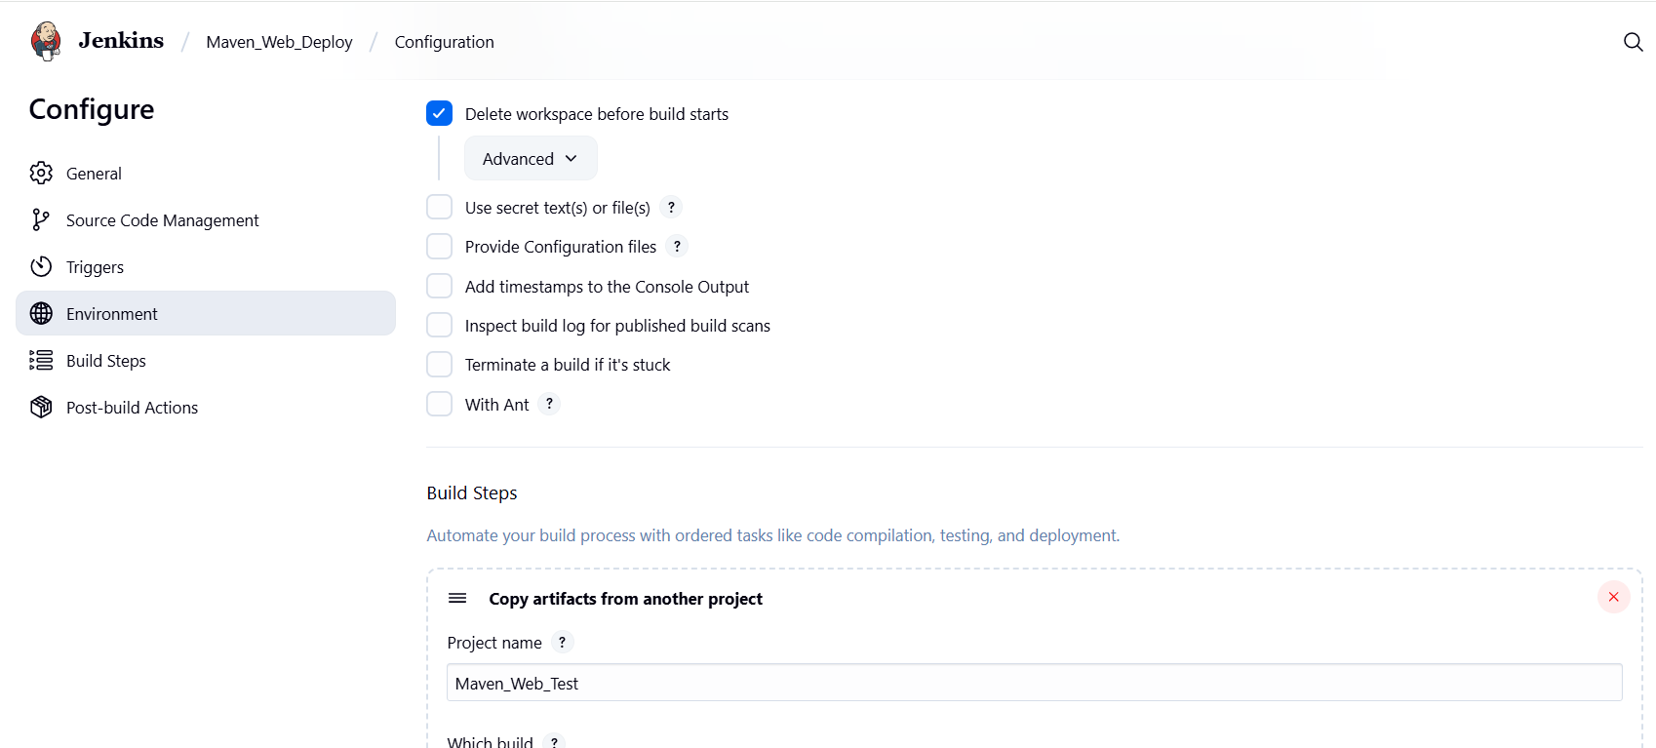
└── Build: Stable build only
└── Artifacts to copy: **/*
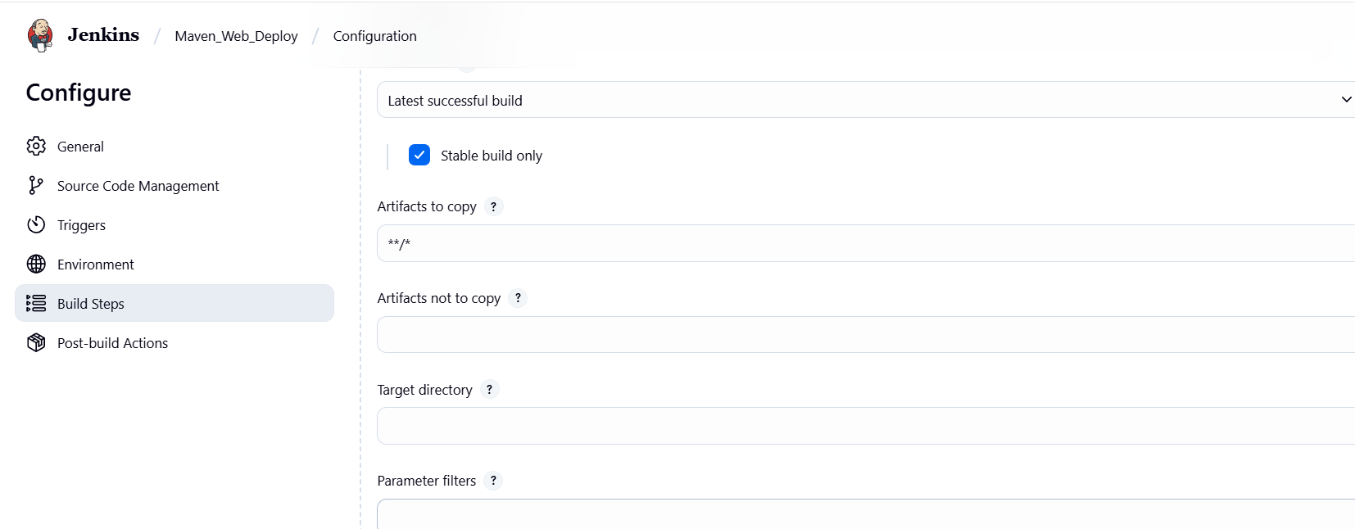
└── Post-build Actions:
├── Add Post Build Action -> "Deploy WAR/EAR to a container"
└── WAR/EAR File: **/*.war
└── Context path: Webpath
└── Add container -> Tomcat 9.x remote
└── Credentials: Username: admin, Password: 1234
── Tomcat URL: https://localhost:8085/
└── Apply and Save
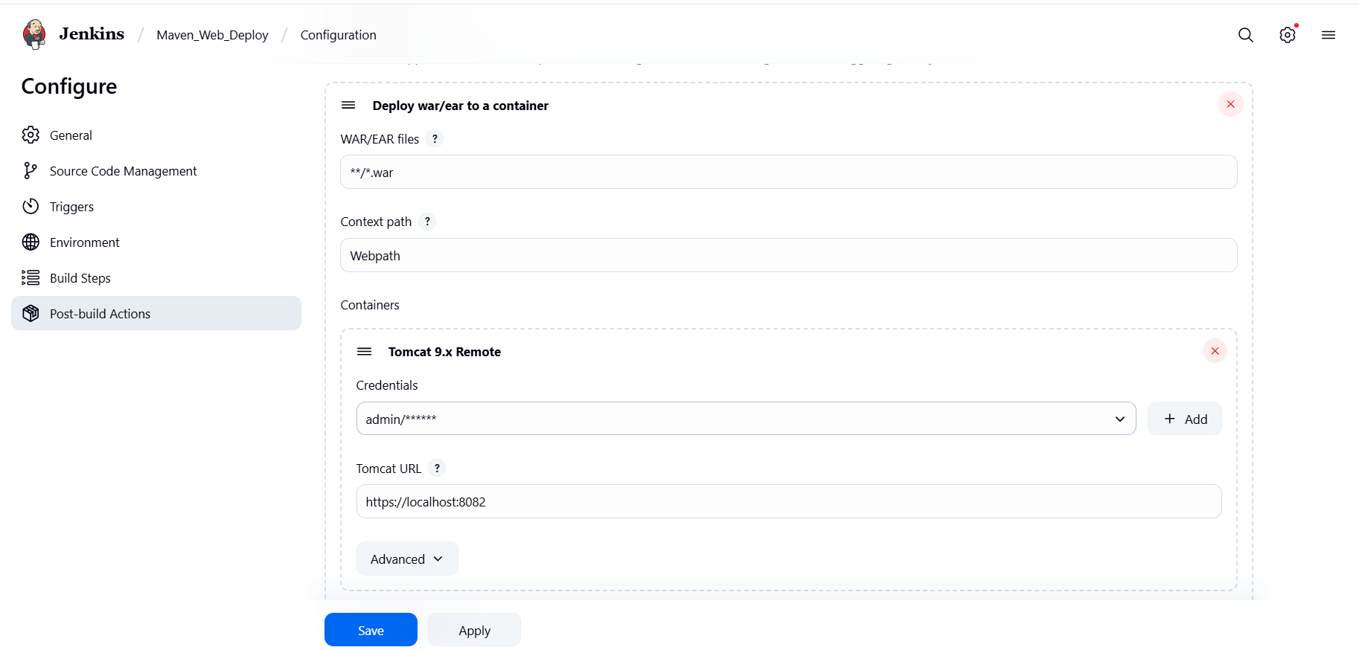

└── Step 5: Create Pipeline View for MavenWeb
├── Click "+" beside "All" on the dashboard
├── Enter name: MavenWeb_Pipeline
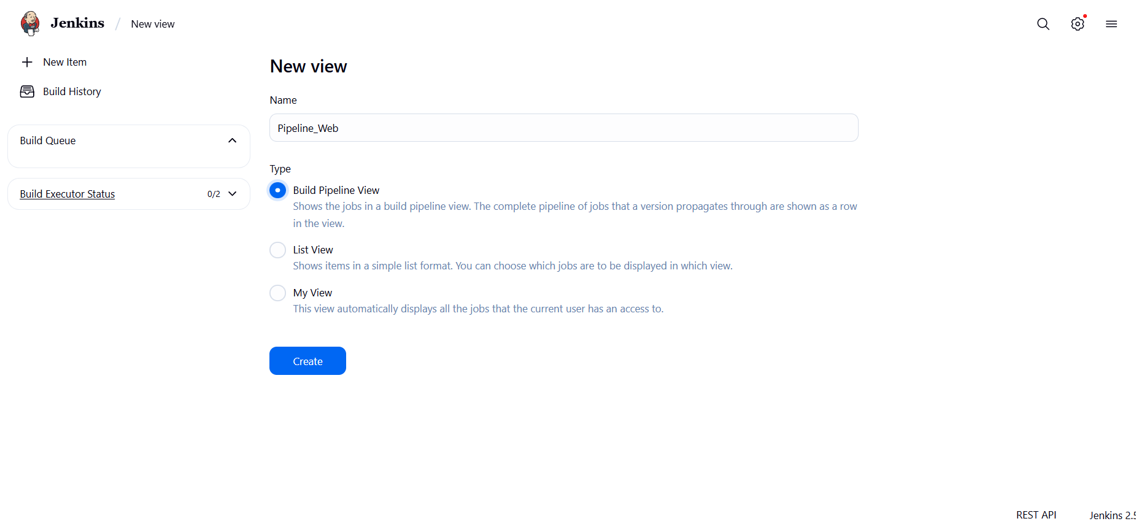
├── Select "Build pipeline view"
└── Pipeline Flow:
├── Layout: Based on upstream/downstream relationship
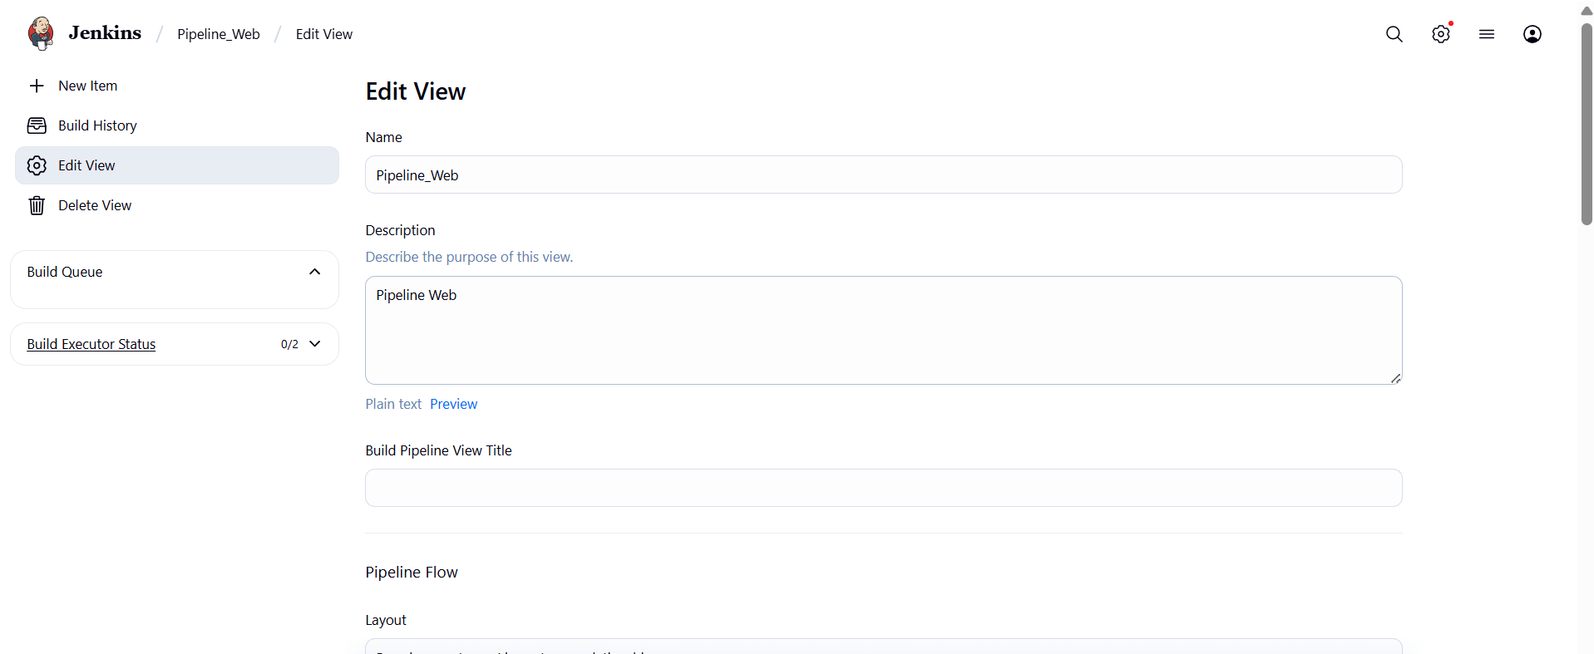
├── Initial job: MavenWeb_Build
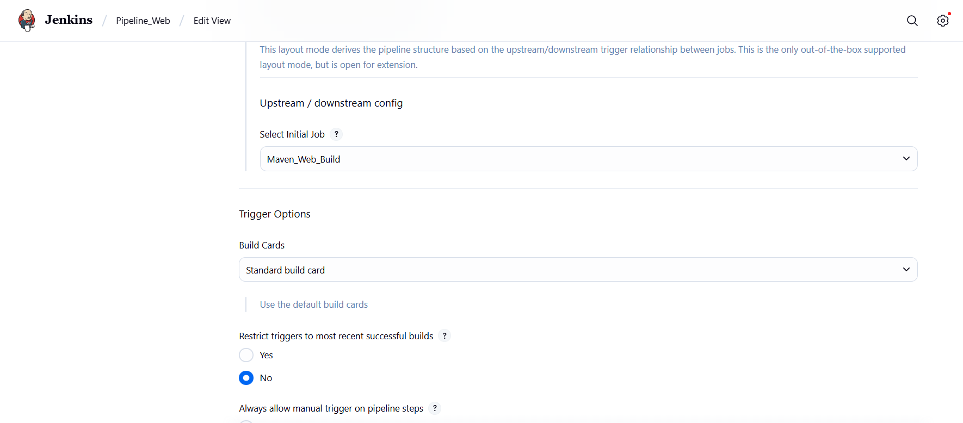

└── Apply and Save
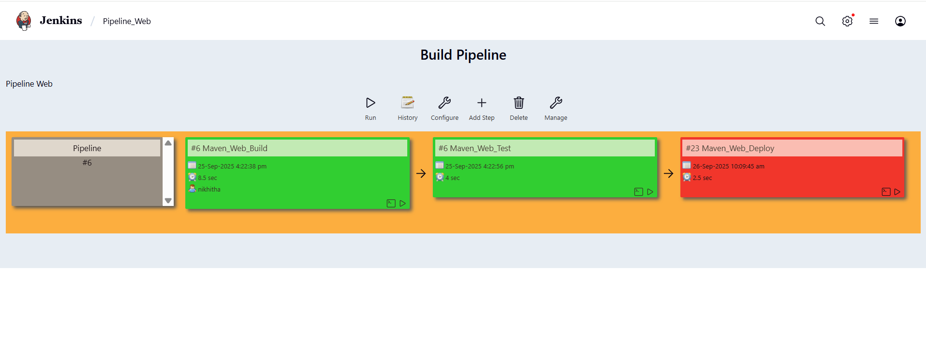

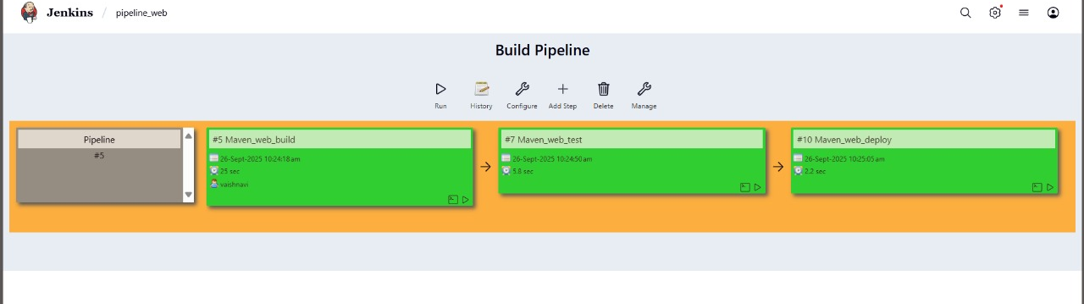

Started by upstream project "Maven_web_test" build number 7
originally caused by:
Started by upstream project "Maven_web_build" build number 5
originally caused by:
Started by user Nikhitha
Running as SYSTEM
Building in workspace C:\ProgramData\Jenkins\.jenkins\workspace\Maven_web_deploy
[WS-CLEANUP] Deleting project workspace...
[WS-CLEANUP] Deferred wipeout is used...
[WS-CLEANUP] Done
Copied 20 artifacts from "Maven_web_test" build number 7
[DeployPublisher][INFO] Attempting to deploy 1 war file(s)
[DeployPublisher][INFO] Deploying C:\ProgramData\Jenkins\.jenkins\workspace\Maven_web_deploy\target\WEB1.war to container Tomcat 9.x Remote with context /Webpath
[C:\ProgramData\Jenkins\.jenkins\workspace\Maven_web_deploy\target\WEB1.war] is not deployed. Doing a fresh deployment.
Deploying [C:\ProgramData\Jenkins\.jenkins\workspace\Maven_web_deploy\target\WEB1.war]
Finished: SUCCESS
└── Step 6: Run the Pipeline and Check Output
├── Click on the trigger “RUN” to run the pipeline
Note:
- After Click on Run -> click on the small black box to open the console to check if the build is success
- Now we see all the build has success if it appears in green color
├── Open Tomcat homepage in another tab
├── Click on the "/webpath" option under the manager app

Note:
- It ask for user credentials for login ,provide the credentials of tomcat.
- It provide the page with out project name which is highlighted.
- After clicking on our project we can see output.

- Questions on Jenkins
- What is Jenkins primarily used for?
- Jenkins are used for continuous integration and continuous deployment(CI/CD) to automate building,testing and deployment.

- What is feature of Jenkins?
- 1) Extensibility through plugins
2) Pipeline as code
3) Distributed builds across multiple nodes.
4) Integration with version control systems.

- What is the default port on which Jenkins runs?
- The default port for Jenkins is 8080.

- What can be integrated with Jenkins for version control?
A) Git,GitHub
- What is the purpose of Jenkins plugins?
A)Plugins extend Jenkins functionality by adding new integrations , build steps, SCM support and pipeline features.
- Which type of Jenkins job is best suited for running one-off tasks or small scripts?
A) Freestyle Job
- How can you manage sensitive information such as API keys in Jenkins?
A)Using the Credentials Plugin, which stores secrets anf injects them into the build.
- What does the "blue ocean" feature in Jenkins refer to?
A)A modern, user-friendly UI for Jenkins pipeline with visualization of stages and steps
- Which Jenkins component allows for distributed builds across multiple machines?
A) Jenkins Master-Agent architecture
- List at least five Jenkins plugins that you would consider important for a microservices-based application CI/CD pipeline. Briefly explain the purpose of each plugin.
A) 1)Maven Integration Plugin – Lets Jenkins build and manage java projects using Apache Maven
2)Build Pipeline Plugin – visualizes and manages chained jobs as a pipeline view
3) Pipeline Utility Steps Plugin – provides helper steps inside pipelines
4) Copy Artifact Plugin – copies build artifacts from one job to another for reuse
5) Deploy to Container Plugin – Deploys built applications directly to app servers
6) Git SCM / Git Pipeline Plugin (Blue Ocean) – Integrates Git repositories into Jenkins pipelines with Blue Ocean Visualization.

- Explain the steps you would take to install a plugin in Jenkins through the Jenkins UI. What considerations would you keep in mind regarding plugin compatibility and updates?
- Go to Manage Jenkins -> Manage Plugins
Search in available tab
Select plugin ->Click on install without restart
Considerations:
Ensure plugin version is compatible with Jenkins version
Check for dependency requirements
Avoid outdated or unmaintained plugins
- After installing a plugin, explain how you would configure it within Jenkins. For example, if you installed the Git Plugin, what steps would you take to set it up for your pipeline?
A) 1)Go to Manage Jenkins - > Global Tool Configuration
2) add Git installation path
3)in your pipeline,configure git URL and credentials
4)test connection to ensure Jenkins can access the repo
- Discuss common issues that might arise when using Jenkins plugins, such as dependency conflicts or version compatibility problems. How would you troubleshoot these issues?
- 1)Dependency conflicts -one plugin may require different version of another
2)Version Incompatibility – Plugins may not support the installed Jenkins core
3)Security Vulnerabilities -Outdated plugins may have security issues.
Troubleshooting:
1)Check Jenkin logs
2) Upgrade/downgrade plugin versions carefully.
3) Use Jenkins Plugin Manager -> Updates to patch issues.
4) If broken, uninstall plugin or roll back using a backup.

Conclusion: In this week student learnt automating Maven projects through Jenkins.

